

**Invoice**

|  |  |  |  |
| --- | --- | --- | --- |
|  |  | VAT Reg. # 19141083189 | |
| **United Finance Limited** Camellia House,  22 Kazi Nazrul Islam Avenue,  Dhaka-1000. |  |  |  |
|  |  | Invoice Ref # | UFL/0321/01 |
|  |  | Date | March 28, 2021 |

|  |
| --- |
| **PO Details (Issuer/ Purchaser):**  United Finance Limited  W/O No: Oct/29/20/01  W/O Issue Date: October 29, 2020 |

|  |  |  |
| --- | --- | --- |
| SL | DESCRIPTION | Total Price in BDT (including VAT) |
| 1 | Invoice for 30% of total PO value for E-KYC implementation | 567,000.00 |
|  | **Total=** | 567,000.00 |

**Amount in Words:** Taka Five Lac and Sixty Seven Thousand Only.

**Payment Instructions:**

Payment to be made in favor of Sheba Technologies Limited

Account info & Bank Name: Account no: 3101610226001, The City Bank Ltd., New Market Branch

Routing Number: 225263527

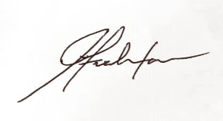 Authorized Signature:

**Farhan Islam**

Senior Manager Business Operations  
Sheba Technologies Ltd.

Phone: +880-1711547804

E-Mail: farhan.islam@shebatech.com.bd